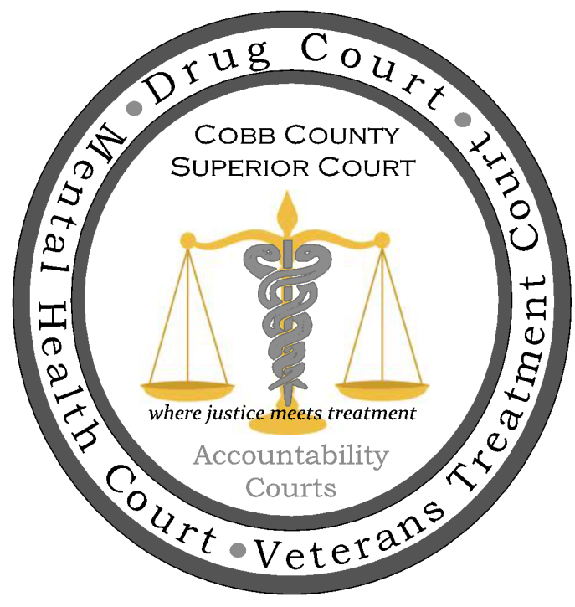

VTC Mentoring

Veteran Treatment Courts offer access to mentor support:
The mentoring component of the Veteran Treatment Court Model is the final and perhaps the most important service which distinguishes VTCs from other types of recovery court programs. Veteran mentors bring their own valuable experience and willingness to serve their comrades in a time of need. Justice involved veterans benefit greatly from the support offered by volunteer mentors as they often require assistance with stabilizing their personal life; housing, employment, education, transportation, as well as someone to help navigate the complex veterans benefit system which fellow veterans are well positioned to do.
“The first day a veteran appears in a Veterans Treatment Court, explains Patrick Welch, who has been recognized for his role in shepherding the Buffalo Veterans Court into being, “The judge points out the volunteer mentors and explains what their role is and tells them that one of the mentors will go out into the hall with each of them after each court session.” Mentors are not counselors. They are not employed by the judicial system; they do not report to the judge what they say to and hear from one of their charges [unless one of their charges threatens to harm himself or others, or commit a crime]. Rather, they function as a battle buddy.”
Veteran peer mentors are all-important buttresses to the Veterans Treatment Court team. Ongoing interaction by mentors with program participants is imperative. Their active, supportive relationship, maintained throughout treatment, increases the likelihood that a veteran will remain in treatment and improves the odds for sobriety and law-abiding behavior.
V. Role of the Veteran Mentor
Desirable traits of a veteran mentor:
- A listener who builds trust by keeping confidences of others.
- One who supports veterans, especially when things aren’t going well, understanding the importance and necessity of accessing substance abuse/mental health treatment and recovery support services determined by clinical professionals to provide that support.
- A volunteer who has the time, flexibility and availability to help when needed, willing to be trained in doing things that result in long-term success for the veteran being served.
- One who guides, and is a role model and becomes a resource, willing to share experiences that lead to success and/or failure.
- A collaborator with others on the recovery team, both volunteer and professional, who willingly follows directions from Court, State and Federal authorities while advocating the best outcomes for the veteran.
Mentor Component
An essential component of the Veterans Treatment Court program is the mentor program where veteran mentors act as peer support to veteran participants. Veterans are better served by having a support system that includes veterans who understand combat experience and the different aspects of military service. Mentors participate in a supportive relationship with participants to increase the likelihood that they will remain in treatment, attain and manage sobriety, maintain law-abiding behavior and successfully readjust to civilian life. The mentor program consists of mentor coordinators and veteran mentors. Their roles, responsibilities, requirements and qualifications are discussed in the following sections.
The Duties (Roles) and Responsibility of a Veteran Mentor
Veteran mentors are veteran volunteers responsible for serving as a supporter, guide and confidant for veteran participants. Mentors should provide support as participants’ progress through the Veterans Treatment Court and should feel comfortable working collaboratively to assist participants in successfully completing the directives of the court.
Veteran mentors should:
1. When meeting with participants to assist in resolving their issues:
- Each meeting should build on the participants’ previous conversation
- Meetings should be conducted in person (when possible)
- Refer participants to appropriate services
- Facilitate an understanding of courtroom procedures
- Maintain appropriate boundaries with participants
- Be respectful and always speak with a positive tone
When meeting with participants, MENTORS MUST NOT:
- Make clinical recommendations
- Give legal advice
- Provide psychotherapy
- Utilize a stern approach
- Inappropriately extend the boundaries of their relationship
- Offer or give monetary gifts
- Post bond for mentee
2. Mentors should work collaboratively with the other mentors and the mentor coordinator.
3. Motivate participants utilizing a strengths-based approach by:
- Providing encouragement to participants by highlighting their strengths including, talents, skills and knowledge
- Focusing on what has been successful
- Believing that participants have the potential to learn, grow and change
4. Maintain federal and state confidentiality standards.
5. Attend clinical and legal training programs supported or provided by the Veterans Treatment Court.
- Mentors should attend an initial training session where topics may include: Veterans Treatment Court’s policies and procedures, mentoring dos and don’ts, substance abuse, mental illness, Post-Traumatic Stress Disorder and Traumatic Brain Injury.
6. Communicate with their mentor coordinator to resolve any issues regarding time commitments, resistant participants or unmanageable challenges.
- If a mentor fears for the safety of a participant’s life call 911 and then report to the mentor coordinator immediately.

Requirements and Qualifications for Veteran Mentors
Mentors should:
- Complete a mentor application form (sample is attached)
- Provide a valid DD214 or DD215
- Submit to a background check
- Be respectful of individual differences and maintain appropriate boundaries with participants
- Not be an active employee of law enforcement or a member of any other organization that may present a conflict of interest with the mentor program
- Commit to a time period of (individual courts determine the amount of time as some require 18 to 24 months commitment)
Communication
- Communication with Justice Involved Veterans, Mentee, is often key to their success in the VTC Program.
- Veteran Mentors will meet with their individual Mentee during Mentee’s required presence in VTC either before or after their meeting with the VTC Judge.
- Veteran Mentors are encouraged to communicate with their Mentee via Phone Call, Email or Text in between court appearances.
- If the Venter Mentor does not hear from their Mentee at least every other week they should call their individual veteran to see how they are doing with their own personal goals and the goals set out by the VTC’s Case Worker.
- VTC Mentor will communicate any and all concerns of a Mentee being personal risk or a risk to others life or limb to the Mentor Coordinator or VTC Staff ASAP. If the Mentor is physically present with their At-Risk-Mentee they will, not leave the Mentee and call 911 to report their concerns and inform the Mentor Coordinator or VTC Staff when time permits. If on the phone with the At-Risk-Mentee they will call 911 to get assistance to the Veteran, inform the Mentor Coordinator or VTC Staff when time permits.

Mentor Ethics and Boundaries
- The primary responsibility of the Mentor is to help veterans achieve their own needs, wants and goals.
- Mentors will maintain high standards of personal and professional conduct.
- Mentors will conduct themselves in a manner that does not jeopardize their own well-being.
- Mentors will openly share with other mentors, veterans and non-veterans their own recovery stories from mental illness, substance abuse, or co-occurring disorders as appropriate for the situation in order to promote recovery and resiliency.
- Mentors will, at all times, respect the rights, dignity, and privacy of those they serve.
- Mentors will never intimidate, threaten, harass, use undue influence, use physical force, use verbal abuse, or make unwarranted promises of benefits to the individuals they serve.
- Mentors will not practice, condone, facilitate, or collaborate in any form of discrimination or harassment based on ethnicity, race, color, pregnancy, veteran’s status, sex, sexual orientation, age, religion, national origin, marital status, political belief, mental or physical disability, or any other category protected by state and/or federal civil rights/laws.
- Mentors will promote self-direction and decision making for those they serve.
- Mentors will respect the privacy and confidentiality of those they serve.
- Mentors will promote and support services that foster full integration of individuals into the communities of their choice.
- Mentors will be directed by the knowledge that all individuals have the right to live and function in the least restrictive and least intrusive environment.
- Mentors will not enter into dual relationships or commitments that conflict with the interest of those they serve. This includes but not limited contracts for work, lodging or financial commitment between the Mentor and Mentee or eithers family members’.
- Mentors will never engage in sexual or other inappropriate activities with those they serve.
- Mentors will not use illegal substances, misuse alcohol, or other drugs (including prescription medications).
- Mentors will keep current with Court and Recovery Team policies and practices and ensure changes are reported to the Mentor Coordinator and shared with other mentors.
- Mentors will not accept gifts of significant value from those they serve.
- Mentors will not provide services beyond their qualifications. This includes diagnosing a condition or illness, recommending medications, or acting as a clinician.
- A review of this Code will be conducted annually.
- Violations of the Code will result in a review by the VTC Director and Mentor Coordinator and may result in mentor status and/or disciplinary action.
Challenging situations will inevitably arise for mentors working with justice involved veterans. Mentors should be aware that veterans may be uncomfortable asking for, or accepting assistance:
“military values and the warrior ethos become part of a collective identity that involves loyalty, duty, respect, selfless service, honor, integrity, and personal courage. The warrior ethos, grounded in these values, refers to a code of professional conduct that involves putting mission first, never accepting defeat, never quitting, and never leaving a fallen comrade (U.S. Department of the Army, 2006). Assuming a “sick role” is contrary to this idealized self-image, and may predispose individuals to avoid seeking help for a substance use or psychological problem (DOD Task Force on Mental Health, 2007; Tanielian & Jaycox, 2008).”
As a mentor, it is essential to understand the proper protocol for responding compassionately and effectively to complex situations, whether they are ethical, procedural or safety related. Mentors can review the Boundaries and Decision Making Tree illustrated below:
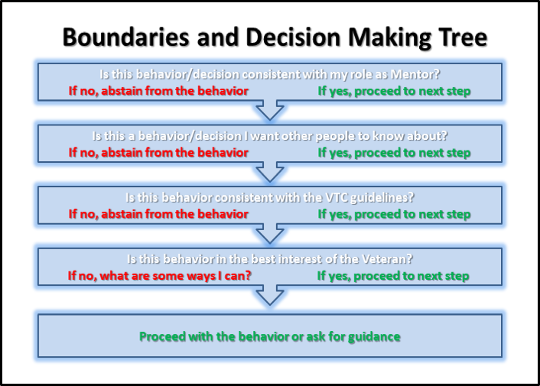
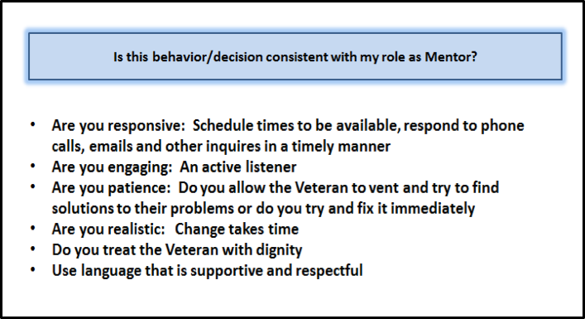
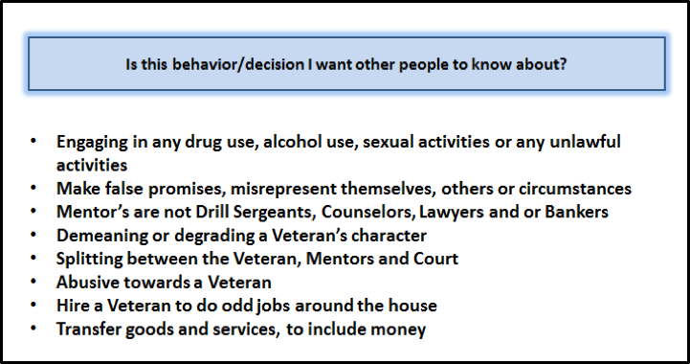
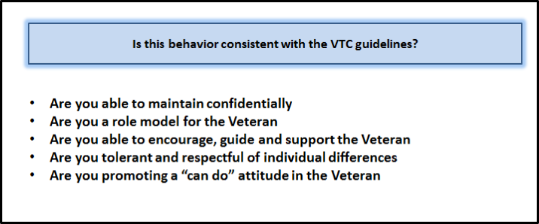
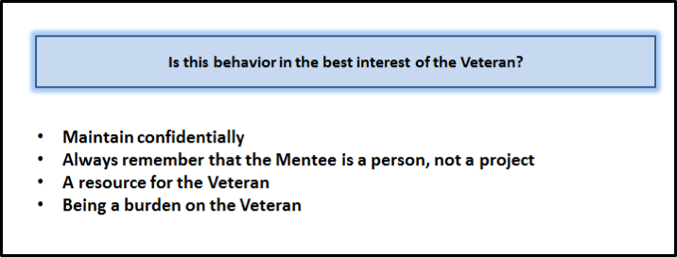

Collaborating with Veterans Agencies and Organizations

Why we work with Veteran Agencies and Organizations
- The work of Veterans’ Treatment Court relies on cooperation and positive proactive relationships with many partners to get the job done. We simply must work together, or we can’t help justice-involved veterans. This is the same teamwork approach used in the military. Veterans’ Treatment Courts collaborate with veteran agencies, organizations and even individuals, like private-practice therapists who understand the problems veterans face.
- The size of the population is too great to go it alone. Literally millions of veterans have served, and thousands of these millions will need special services and may become justice involved, often as a direct result of that service. As a result:
- Every veteran agency and organization has a sense of being overwhelmed. Working together is the only sane way to address the issue.
- Synergy is the goal. “The sum of the whole is greater than the sum of the parts” becomes true when we collaborate instead of just tolerate others who have a similar agenda. Every veteran agency, organization, or individual has an agenda to help veterans. When we choose to work together with cooperation, positive energy and proactive leadership a new equation results. One plus one becomes more than two, every time. Your energy plus someone else’s energy directed positively can create synergy.

Building Positive Relationships with Veteran Agencies and Organizations
1. Trust: The Key to Working Together
- Trust is a choice. The whole thing starts with believing in one another, and it will end if and when we stop believing in one another. We know this work is going to take a lot of people working together, and that means we will need to extend trust to others.
- “The good news is trust begins with you: Your attitudes, your intentions, and your behaviors within your relationships. This is good news because you’re in control of these things...”
- Trust is either being built or destroyed in each action you choose to take in a relationship.
- You must earn the trust of the Veteran Agencies, Organizations and individuals you work with.
2. “Seek first to understand, then seek to be understood” said noted relationship coach Stephen Covey
- As you select Veteran Agencies and Organizations to work with, do your homework
- Find out what matters to them and what they most want to get done.
- Align what you ask them for with what they want. Example: “It would help us help you if...”
3. Earn trust by saying what you can do (avoid over-promising and under-delivering) and then be sure to do it.
“No surprises”: Keep your partners in this work informed. If there is a problem, let them know before they find out, and work on a solution that builds trust.

